BOARDINGHOUSE MANAGEMENT SYSTEM

__________

A Project Presented to
Mr. Joseph M. Pequit of the College of Computing and Information Sciences
BOHOL ISLAND STATE UNIVERSITY
Balilihan Campus
Magsija, Balilihan, Bohol

__________

In Partial Fulfillment
of the Requirements for the Subject
CC 221 Database Management System 2

Joshua | S. | Banawan
Sharmaine |  | Calabio
Glendo | W. | Navarez
Rudmark |  | Renion
Bea | A. | Sarong

May 2025
SCOPE AND LIMATIONS

A boarding house management system acts as a central digital hub, designed to streamline the fundamental operations of running a boarding house. Its functionalities cover a wide range of essential tasks, including comprehensive tenant management from initial registration and the handling of lease agreements to the efficient assignment of rooms and the management of move-out procedures. To facilitate smooth communication, the system also incorporates dedicated tools for interaction with tenants. Beyond tenant-related tasks, the system provides robust room and inventory management features, allowing for detailed tracking of room information and the oversight of shared resources. Furthermore, it simplifies crucial financial processes by automating rent calculations, meticulously tracking payments, managing any overdue balances, and generating necessary invoices for record-keeping. Integral to the system is its maintenance and issue tracking capability, which enables the efficient logging, assignment, and monitoring of maintenance requests, while also maintaining a valuable history of all completed work.
However, it's important to recognize the typical boundaries of such a system. It generally does not encompass more complex accounting functionalities, comprehensive human resources management tools, integration with advanced physical security systems, marketing and property listing capabilities, sophisticated facility management features for building systems, or community-building functionalities aimed at fostering tenant interaction. While these systems are highly effective in addressing the core administrative and operational demands of managing tenants, rooms, and finances within individual or small-scale boarding house environments, potential limitations can arise. These may include challenges in scalability for larger operations, restrictions in the degree of customization available to meet unique needs, difficulties in achieving seamless integration with external platforms or specialized software, the level of technical expertise required for successful implementation and ongoing maintenance, and the overall scope of features dedicated to comprehensive data security and privacy management.

OBJECTIVES

- To develop a comprehensive web-based boarding house management system that centralizes tenant information, room and bed assignments, and payment tracking in one platform.
- To implement a role-based access control system that provides different privileges for administrators and tenants, ensuring data security and appropriate user interactions.
- To automate the monthly billing process by calculating rent based on base rates plus additional fees for appliances, then generating and distributing payment notices to tenants.
- To create a digital tracking system for monitoring room occupancy, bed availability, and tenant status (active/left) to optimize boarding house capacity management.
- To provide tenants with a self-service portal where they can update their personal information, register appliances, and view their billing history and payment status.
- To establish an automated notification system that alerts tenants about upcoming payment due dates, overdue payments, and important announcements from management.
- To develop a comprehensive reporting system that generates insights on occupancy rates, payment collection status, and revenue trends to support administrative decision-making.
- To digitize the tenant onboarding and offboarding processes, making tenant registration, room assignment, and departure procedures more efficient and organized.
- To create a secure database that maintains historical records of all tenant information, payments, and billing cycles for audit and reference purposes.

ENTITY RELATIONSHIP DIAGRAM
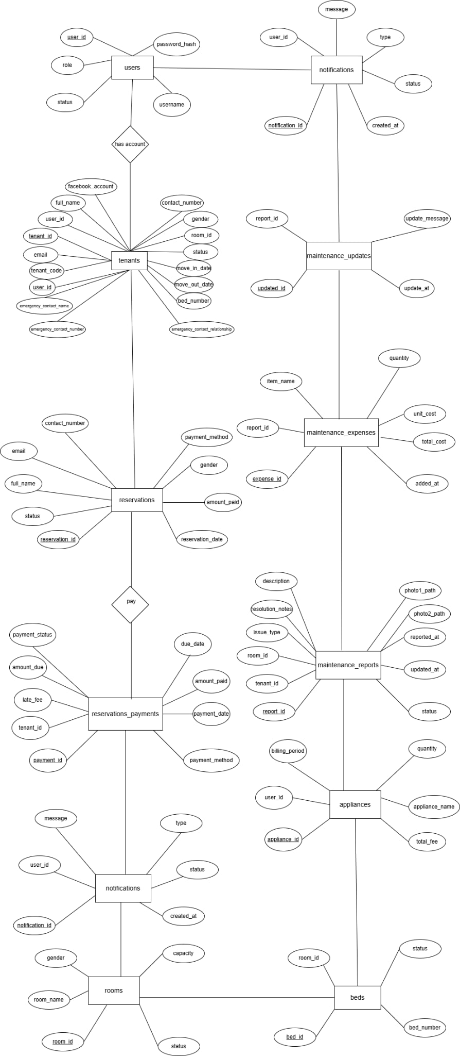

FIGURE 1: ENTITY RELATIONSHIP DIAGRAM
ENTITIES AND ATTRIBUTES
Users Table
Attributes | Primary Keys | Foreign Keys
user_id
username
password_hash
role
status

Tenants Table
Attributes | Primary Keys | Foreign Keys
tenant_id
user_id
full_name
facebook_account
contact_number
email
gender
room_id
move_id_date
move_out_date
bed_number
tenant_code
emergency_contact_name
emergency_contact_relationship
emergency_contact_number
status

Appliances Table
Attributes | Primary Keys | Foreign Keys
appliance_id
user_id
billing_period
appliance_name
quantity
total_fee

Billing Payments Table
Attributes | Primary Keys | Foreign Keys
billing_id
tenant_id
billing_period
amount_due
amount_paid
payment_status
payment_method
due_date
payment_date

Rooms Table
Attributes | Primary Keys | Foreign Keys
room_id
room_name
gender
capacity
status

Beds Table
Attributes | Primary Keys | Foreign Keys
bed_id
room_id
bed_number
status

Reservations Table
Attributes | Primary Keys | Foreign Keys
reservation_id
full_name
contact_number
email
gender
status
reservation_date
amount_paid
payment_method

Reservation Payments Table
Attributes | Primary Keys | Foreign Keys
payment_id
tenant_id
amount_paid
payment_method
payment_status
due_date
payment_date
late_fee

Maintenance Reports Table
Attributes | Primary Keys | Foreign Keys
report_id
tenant_id
room_id
issue_type
description
photo1_path
photo2_path
reported_at
updated_at
status
resolution_notes

Maintenance Updates Table
Attributes | Primary Keys | Foreign Keys
update_id
report_id
update_message
updated_at

Maintenance Expenses Table
Attributes | Primary Keys | Foreign Keys
expense_id
report_id
item_name
quantity
unit_cost
total_cost
added_at

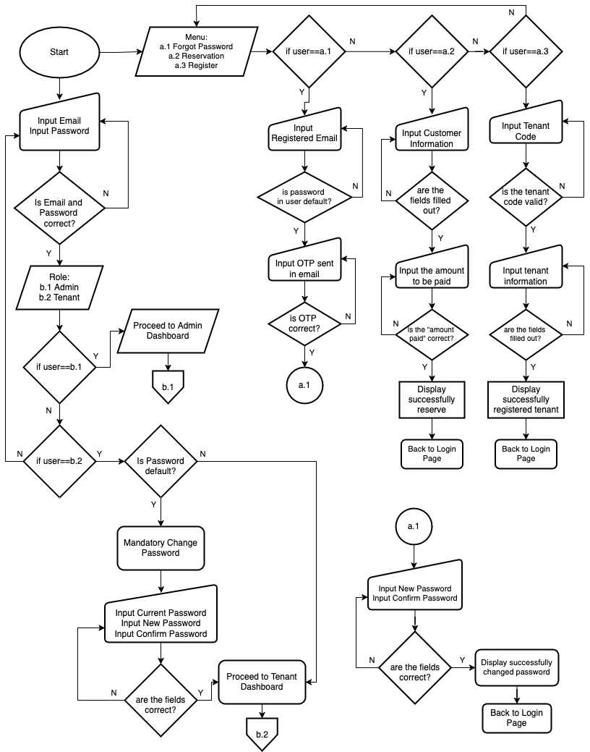
FLOW CHART

FIGURE 2: FLOWCHART BOARDING HOUSE MANAGEMENT SYSTEM

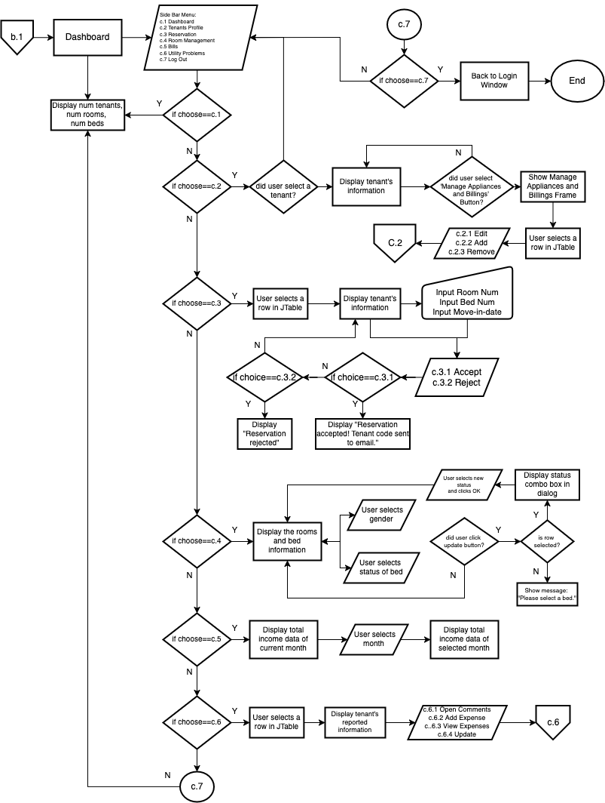
FIGURE 3: FLOWCHART BOARDING HOUSE MANAGEMENT SYSTEM
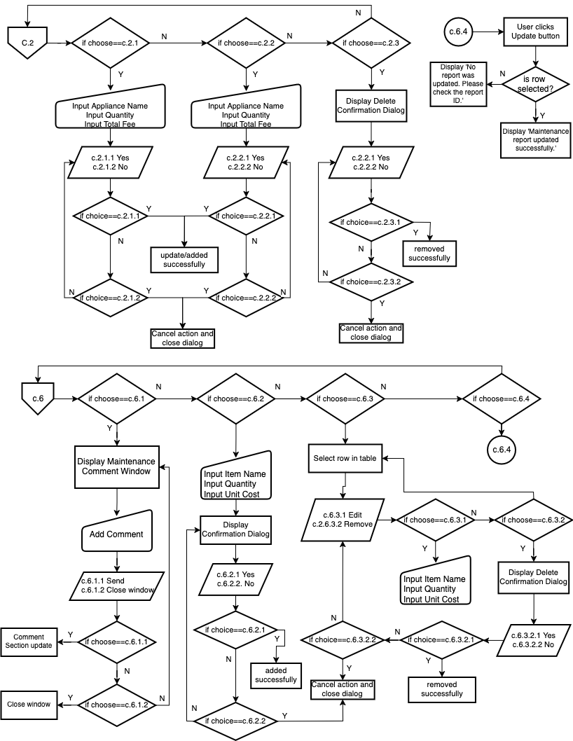
FIGURE 4: FLOWCHART BOARDING HOUSE MANAGEMENT SYSTEM
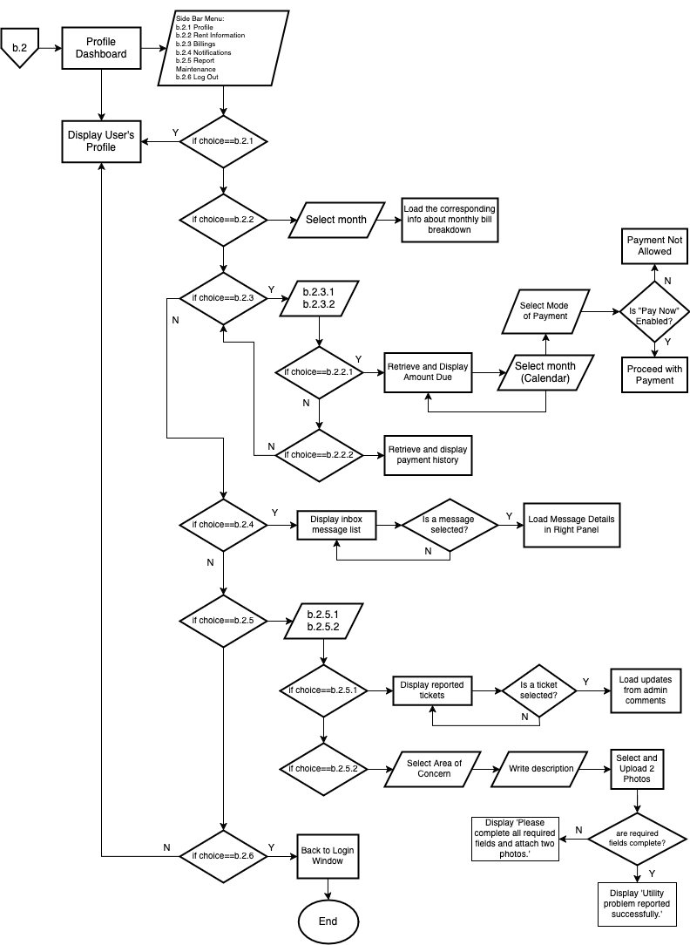
FIGURE 5: FLOWCHART BOARDING HOUSE MANAGEMENT SYSTEM
DATABASE SCHEMA
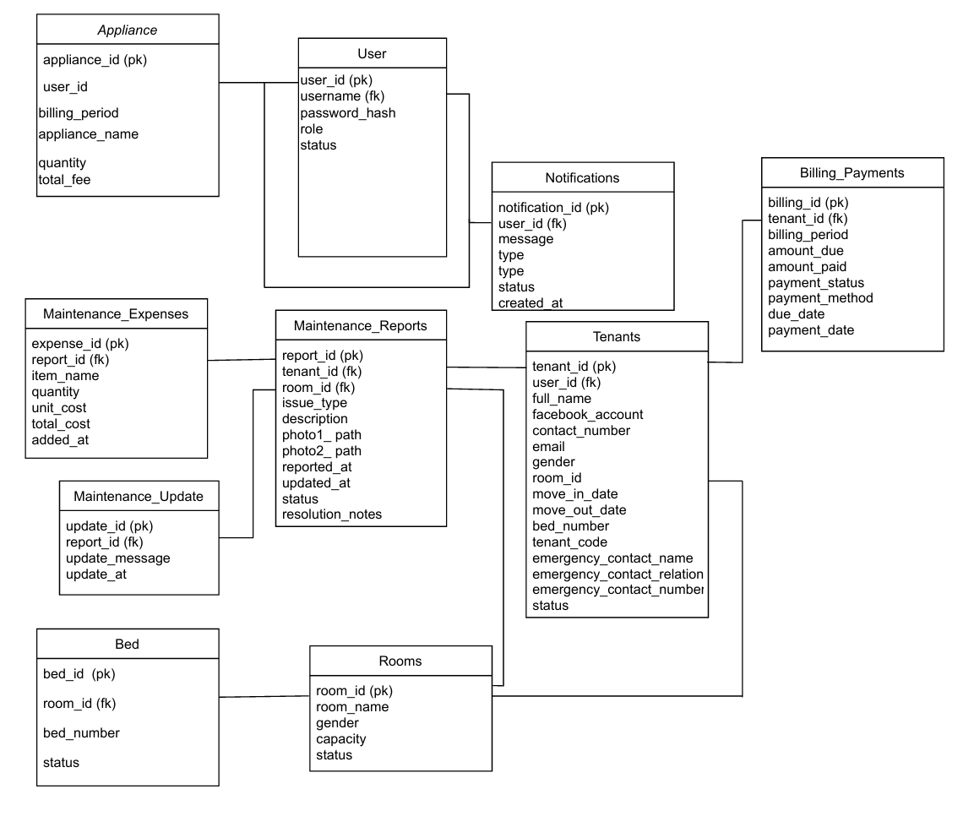
FIGURE 6: Database Schema
SOURCE CODE

public class Login extends javax.swing.JFrame {

public static int userId;
public static int tenantId;
public static int roomId;
public static String currentUser;
public Login() {
initComponents();
setLocationRelativeTo(null);

System.out.println("Panel width: " + rightpanel.getWidth());
System.out.println("Panel height: " + rightpanel.getHeight());
showHideLabel.addMouseListener(new MouseAdapter() {
@Override
public void mouseClicked(MouseEvent e) {
togglePasswordVisibility();
}
});
}
private boolean login(String username, String password) {
Connection conn = DBconnection.getConnection();

if (conn != null) {
try {
String query = "SELECT * FROM users WHERE username = ?";
PreparedStatement stmt = conn.prepareStatement(query);
stmt.setString(1, username);
ResultSet rs = stmt.executeQuery();

if (rs.next()) {
String storedPasswordHash = rs.getString("password_hash");
String role = rs.getString("role");
String status = rs.getString("status");
int userIdFromDB = rs.getInt("user_id");

if (!status.equals("Registered")) {
JOptionPane.showMessageDialog(null, "Your account is not yet registered.");
return false;
}
if (BCrypt.checkpw(password, storedPasswordHash)) {
Login.userId = userIdFromDB;

if (role.equals("Owner")) {
Login.currentUser = "admin";
new admin_dashboard().setVisible(true); // or your actual admin dashboard class
} else if (role.equals("Tenant")) {
// Get tenant info
String tenantQuery = "SELECT tenant_id, room_id, full_name FROM tenants WHERE user_id = ?";
PreparedStatement tenantStmt = conn.prepareStatement(tenantQuery);
tenantStmt.setInt(1, userIdFromDB);
ResultSet tenantRs = tenantStmt.executeQuery();

if (tenantRs.next()) {
Login.tenantId = tenantRs.getInt("tenant_id");
Login.roomId = tenantRs.getInt("room_id");
Login.currentUser = tenantRs.getString("full_name");

String defaultPassword = Login.currentUser.replaceAll("\\s+", "") +
getTenantCode(Login.tenantId);
if (BCrypt.checkpw(defaultPassword, storedPasswordHash)) {
JOptionPane.showMessageDialog(null,
"You are still using the default password.\nPlease change it.",
"Change Password", JOptionPane.INFORMATION_MESSAGE);
new ChangePassword(Login.userId).setVisible(true);
} else {
new tenant_dashboard().setVisible(true);
}
}
}
return true;
}
}
} catch (SQLException e) {
e.printStackTrace();
} finally {
try {
conn.close();
} catch (SQLException e) {
e.printStackTrace();
}
}
}

return false;
}
private String getTenantCode(int tenantId) {
String code = "";
try (Connection conn = DBconnection.getConnection()) {
String query = "SELECT tenant_code FROM tenants WHERE tenant_id = ?";
PreparedStatement ps = conn.prepareStatement(query);
ps.setInt(1, tenantId);
ResultSet rs = ps.executeQuery();
if (rs.next()) {
code = rs.getString("tenant_code");
}
} catch (SQLException e) {
e.printStackTrace();
}
return code;
}

private String getUserRole(String username) {
String role = "";
Connection conn = DBconnection.getConnection(); // Assuming db_connect provides the connection

if (conn != null) {
try {
// SQL query to fetch the user role based on the username
String query = "SELECT role FROM users WHERE username = ?";
PreparedStatement stmt = conn.prepareStatement(query);
stmt.setString(1, username);
ResultSet rs = stmt.executeQuery();
if (rs.next()) {
role = rs.getString("role");
}
} catch (SQLException e) {
e.printStackTrace();
} finally {
try {
conn.close();
} catch (SQLException e) {
e.printStackTrace();
}
}
}
return role;
}
private void togglePasswordVisibility() {
if (password.getEchoChar() == (char) 0) {
password.setEchoChar('*');
showHideLabel.setText("Show");
} else {

setEchoChar((char) 0);
showHideLabel.setText("Hide");
}
}

public String generateOTP() {
Random rand = new Random();
int otp = 100000 + rand.nextInt(900000);
return String.valueOf(otp);
}
public boolean sendOTPEmail(String toEmail, String otp) {
final String fromEmail = "itsbeasarong@gmail.com"; // change
final String password = "sdfu itqy dddw felt"; // use app password, NOT Gmail password

Properties props = new Properties();
props.put("mail.smtp.auth", "true");
props.put("mail.smtp.starttls.enable", "true");
props.put("mail.smtp.host", "smtp.gmail.com");
props.put("mail.smtp.port", "587");

Session session = Session.getInstance(props, new javax.mail.Authenticator() {
protected PasswordAuthentication getPasswordAuthentication() {
return new PasswordAuthentication(fromEmail, password);
}
});

try {
Message message = new MimeMessage(session);
message.setFrom(new InternetAddress(fromEmail));
message.setRecipients(Message.RecipientType.TO, InternetAddress.parse(toEmail));
message.setSubject("Your OTP Code");
message.setText("Your OTP is: " + otp);

Transport.send(message);
return true;
} catch (MessagingException e) {
e.printStackTrace();
return false;
}
}

